After Installing Oracle Virtual Box.

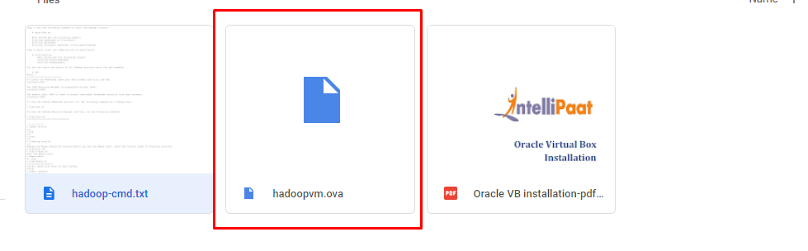

Download and open the “hadoopvm.ova” file

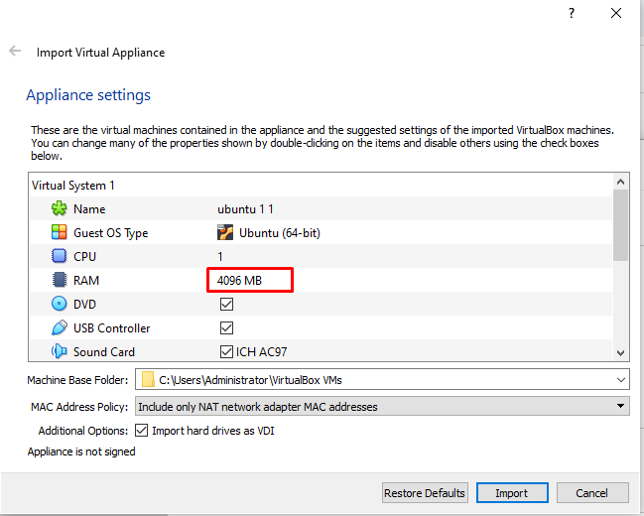

You’ll see a window like this: the recommended memory size is 4096 MB. If you have less RAM on your system you can reduce the default size to 1024 MB or 2048 MB.

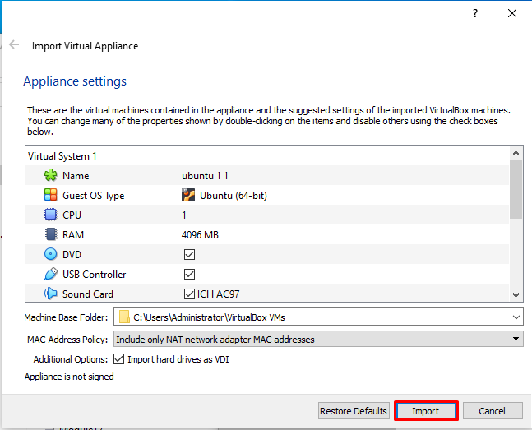

After selecting RAM size click on the “Import” it will set up the virtual machine.

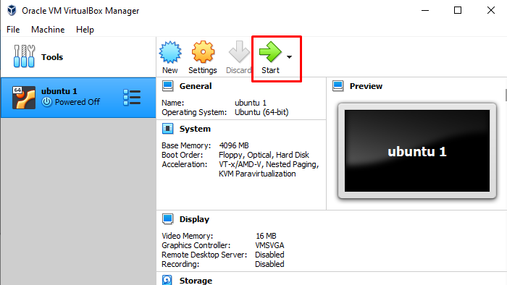

After successful import you will see a virtual machine as shown in the above screenshot.

Now, click on “Start”

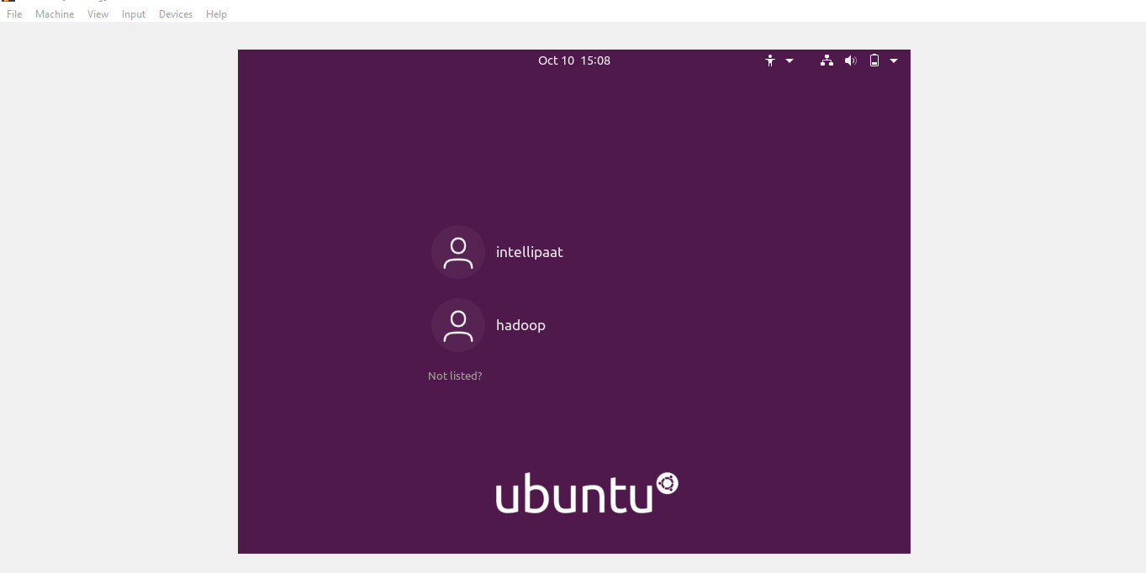

You will see a window like this after opening the virtual machine.

There are two users for using hadoop you need to log in to the hadoop user account.

Username: intellipaat

Password: intellipaat

Username: hadoop

Password: hadoop

After logging in the hadoop user you have to run the commands in “terminal” for setting up the hdfs.

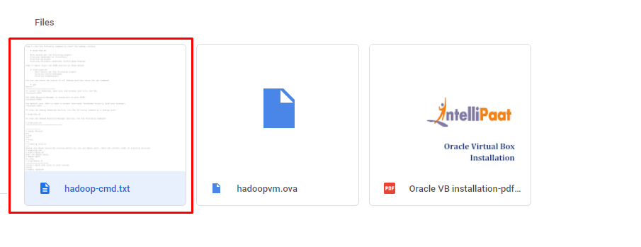

Refer the commands from “hadoop-cmd.txt” file.